Document No. MNGINF/FAC/TMPL/5406 | Transport check form | Document Type: Template

Transport Check Form

Full Name: madipadiga sreeja
Residential Addresses (Please Note: The same address is used for the Transport check)
C/o: m srinivas

House Number/ Name: 9-7-24
Street Name: road no 3
Cross/Main: yadagiri nagar
Area/Nagar: champapet
Post Office: saroornagar
Landmark: opp spark high school
PinCode: 500059

Latitude - 17.347990 / N 17° 20' 52.765”

Longitude - 78.509884 / E 78° 30' 35.582”

I hereby declare that this is my residential addresses. I understand that the offer letter will be valid only if I am residing at this address and in case of relocation, I will abide to relocate within the transport boundary of Infosys.

Name: madipadiga sreeja

Date: 06-05-2025

Signature : madipadiga sreeja

== =================================================================================
For office use only:

Status | Approved | Out of Boundary
Name & Signature | <Name> | <Signature>

HOW TO IDENTIFY LATITUDE AND LONGITUDE ON GOOGLE MAP

VISIT GOOGLE MAP

WRITE YOUR LOCATION IN SEARCH WINDOW

CLICK RIGHT ON THE LOCATION POINT

CLICK RIGHT ON Whats here ?

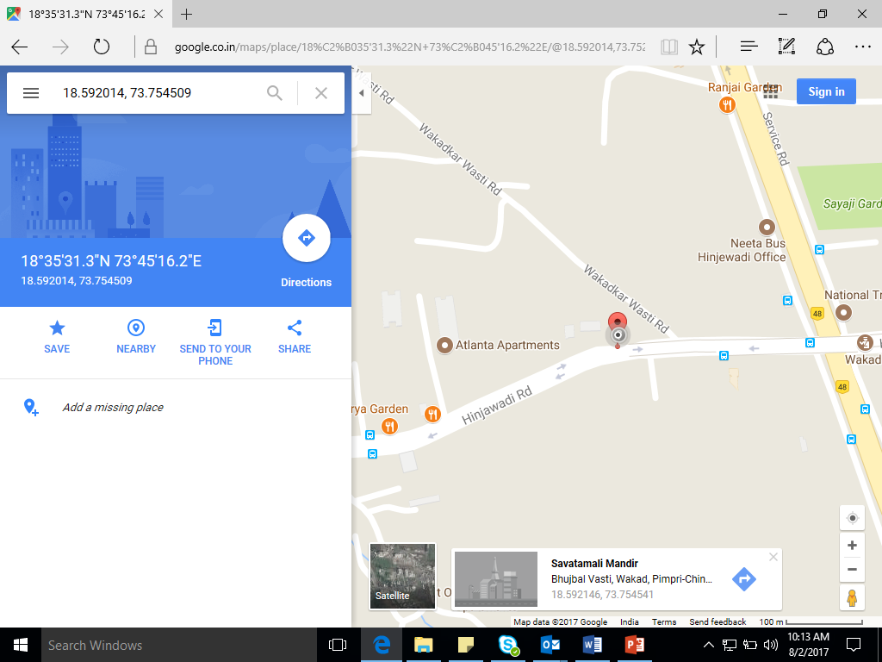

YOU CAN VIEW LATITUDE AND LONGITUDE. COPY THE SAME AND UPDATE IT.

THANK YOU

